ANNEX A

Migrant Domestic Workers and Employer Engagement Survey with 2,545 respondents comprising 257 employers and 2,288 migrant domestic workers; conducted by CDE from April to May 2024.

Chart 1 With 257 Employers

Are there any courses you are keen for your helper to participate in? (Select all that apply) (N=257)
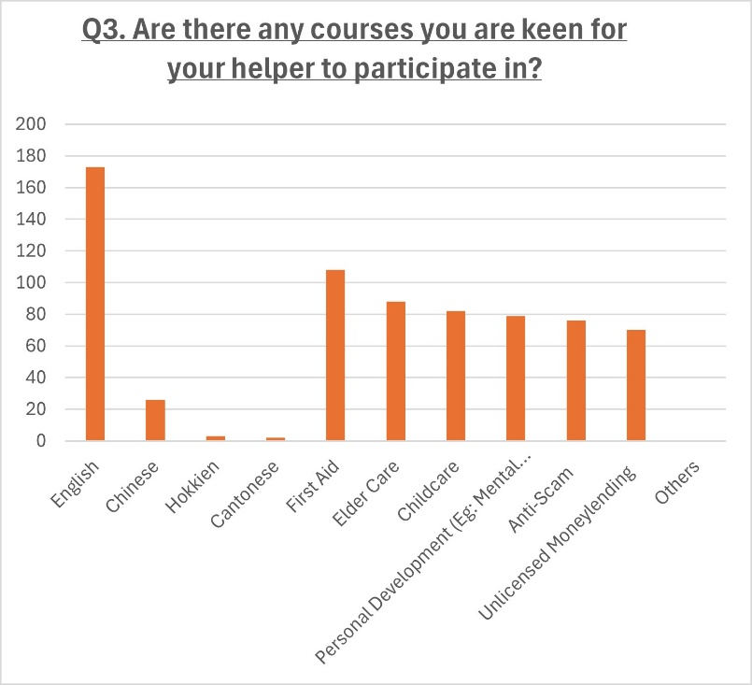
Chart 2 With 2288 Migrant Domestic Workers

Are there any courses you like to go for? (Select all that apply)
(N=2288)
