# ANNEX A

**Chart 1**

**Older workers’ interest in pursuing training opportunities.** (N=368, aged 55 and above)

**Interested, 92%**

**Not Interested, 8%**

Survey with 1,000 respondents, aged 40 and above; conducted from Jan to Feb 2022.

**Chart 2**

# Do you feel that older workers have fewer training opportunities compared to younger workers in your company? (N=368, aged 55 and above)

50%

**48%**

40%

**32%**

**15%**

**5%**

30%

20%

10%

0%

Strongly Agree Agree Disagree Strongly Disagree

Survey with 1,000 respondents, aged 40 and above; conducted from Jan to Feb 2022.

**Chart 3**

**Proportion of Workers who Attended Training Start Declining with Age.**

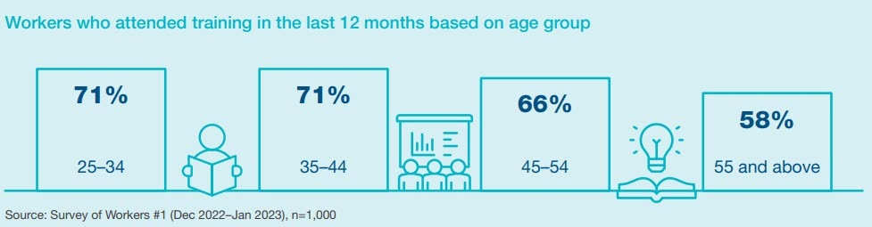

Survey with 1,000 respondents, aged 20 and above; conducted from Dec 2022 to Jan 2023.